Predicting The Hardness of Low Alloy Metal Using Machine Learning Model
978-1-6654-8035-2/22/$31.00 ©2022 IEEE

Authors Name/s per 1st Affiliation (Author)
line 1 (of Affiliation): dept. name of organization
line 2: name of organization, acronyms acceptable
line 3: City, Country
line 4: e-mail address if desired
Authors Name/s per 2nd Affiliation (Author)
line 1 (of Affiliation): dept. name of organization
line 2: name of organization, acronyms acceptable
line 3: City, Country
line 4: e-mail address if desired

Abstract— The growing need in materials science for accurate hardness prediction highlights how important accurate modeling is to process optimization in materials engineering. Since accurate hardness estimates are essential for material selection, design, and manufacturing, it is highly suggested to use them. The use of machine learning (ML) models for hardness prediction is examined in this work, with particular attention paid to algorithms like Random Forest, Gradient Boosting, Decision Tree, and Multilinear regression. Based on factors like model complexity, training effectiveness, and adaptation to various material properties, the study assesses these algorithms. Predictive performance indicators like as root mean square error (RMSE), R2 score, and computing efficiency are evaluated through comparative analyses conducted on diverse datasets. The significance of objective predictions in materials engineering is emphasized by a discussion of ethical issues with bias and fairness in ML models.The insights presented in this study add to the expanding body of knowledge in materials science and give a basis on which practitioners, researchers, and decision-makers can make well-informed decisions when choosing machine learning methods for robust hardness prediction.
The conclusion highlights the ongoing need for specialized methods to meet changing obstacles in materials science prediction and offers directions for future study.

Keywords- : Hardness prediction,Machine learning models,Materials science, Model evaluation,Ethical considerations.
Introduction
The accurate prediction of hardness in materials science is a critical pursuit, given its paramount importance in influencing material selection, design, and manufacturing processes. Hardness, as a fundamental mechanical property, serves as a key indicator of a material’s resistance to deformation and wear, making it a pivotal factor in ensuring the reliability and longevity of engineered components. As industries increasingly seek precision and efficiency in materials engineering, the demand for reliable hardness prediction models has surged.Traditional approaches to hardness prediction often rely on empirical correlations and manual experimentation, which can be time-consuming and resource-intensive. In response to these challenges, the integration of machine learning (ML) models has emerged as a promising avenue, offering the potential for accurate and efficient hardness predictions. This paper explores the application of various ML algorithms, including Multilinear Regression, Decision Tree Regressor, Gradient Boosting Regressor, and Random Forest Regressor, to address the complexities inherent in predicting hardness across diverse materials.Beyond the technical aspects, this study considers the ethical dimensions of ML models, emphasizing the need for unbiased predictions to ensure equitable outcomes in materials engineering. The comparative analysis of these algorithms on diverse datasets provides valuable insights into their performance metrics, guiding researchers, practitioners, and decision-makers in selecting appropriate models for hardness prediction. As materials science continues to evolve, the findings presented in this paper contribute to the ongoing discourse on enhancing predictive capabilities in hardness assessment. The conclusion not only summarizes the key takeaways from the study but also suggests avenues for further research, recognizing the dynamic nature of challenges in materials science prediction..
Literature Survey

(Swetlana et al., 2020)The model utilizes Gaussian Process Regression (GPR) for predicting Vickers hardness of superalloys, embracing a proba- bilistic approach. Input features encompass structural, compositional, elemental, and processing descriptors. Feature selection is performed through LASSO for model simplicity and interpretability. Pearson correlation coefficient analysis elucidates the linear dependence of descriptors on Vickers hardness. The final GPR model provides accurate predictions, offering valuable insights into the intricate relationships between microstructure, composition, and mechanical properties
(Khalaj et al., 2021)The concept involves employing machine learning techniques—Artificial Neural Network (ANN), Adaptive Neuro-Fuzzy Inference System (ANFIS), and Support Vector Machine Regression (SVMR)—to predict the hardness of Oxide Precipitation Hardened (OPH) alloys. These models are trained using experimental data on alloy composition, heat treatment conditions, and mechanical alloying. The study evaluates the models’ performance, with the ANFIS model demonstrating superior accuracy in predicting OPH alloy hardness. The focus is on understanding the impact of parameters, particularly heat treatment temperature, on the mechanical properties of OPH alloys. Overall, the research showcases the potential of machine learning in material science for predicting and optimizing alloy properties.
(Bhandari et al., 2021)The model utilizes a neural network to predict the hardness of refractory high entropy alloys (RHEAs), focusing on alloy composition features. It employs a supervised machine learning approach with a training dataset containing experimental hardness values. The neural network learns the relationships between alloy composition, including percentages of elements and other material properties, and hardness. The study demonstrates the potential of machine learning, specifically neural networks, as an effective tool for predicting mechanical properties in the design of complex alloys like RHEAs.
(Qiao et al., 2021)The model integrates a Radial Basis Function (RBF) neural network and first-principles calculations to explore the relationship between hardness and elemental descriptors in multi-component alloys. It accurately predicts hardness based on a large database, highlighting aluminum’s significant impact on hardness in an Al–Cr–Fe–Ni system. First-principles calculations on elastic properties validate and complement machine learning predictions. Experimental synthesis of a specific alloy verifies the model’s accuracy, achieving over 90percent predictive success for similar alloys. This approach offers valuable insights for guiding the design of high-performance multi-component alloys.

Methodology Implementation

Task description
Using machine learning (ML) models, this research aims to improve the accuracy of hardness prediction in materials science. There are two main goals to achieve: In task 1, different machine learning techniques for predicting hardness in a range of materials are evaluated. These include Decision Tree Regressor, Multilinear Regression, and others. HardnessDetect, the second task, focuses on the complex environment of material hardness prediction and outcomes classification into Low, Moderate, High, and Very High categories. The goal of the project is to improve hardness prediction efficiency and accuracy while providing useful information for materials science practitioners, academics, and decision-makers.

Dataset description
The dataset provided for the study of steel properties is comprehensive, containing 1466 samples across 17 columns. The dataset encompasses diverse information, including the source of data, steel types, tempering time and temperature, and various chemical composition percentages. This dataset appears well-suited for investigating the relationship between tempering conditions and the final hardness of steel. With key features such as tempering time, temperature, and chemical composition, it offers a valuable foundation for exploring patterns and relationships critical for predicting hardness outcomes. The dataset may be particularly useful for developing machine learning models to predict steel hardness based on tempering parameters. The dataset’s structure aligns with regression tasks, where the goal is likely to predict a numerical outcome, such as the final hardness, using the provided features. Further exploratory data analysis and model development may uncover insights into the nuanced influences of tempering conditions on steel hardness.

No. of rows | No. of Columns
1466 | 17
Table 1: Dataset Description

Proposed Work
The proposed work aims to enhance the precision and efficiency of predicting steel hardness based on tempering conditions through machine learning (ML) techniques, leveraging an extensive dataset encompassing steel type, tempering time, temperature, and various chemical compositions. The initial phase involves exploratory data analysis to understand variable distribution and relationships, including the impact of tempering parameters on final hardness, with feature engineering to enhance predictive capabilities. Subsequently, ML algorithms like Multilinear Regression, Decision Tree Regressor, and others will be employed for model training, fine-tuning, and evaluation using metrics such as root mean square error (RMSE) and R2 score. Ethical considerations regarding bias and fairness in steel hardness prediction models will be addressed to ensure equitable outcomes. Detailed content for each algorithm will include training and test data, classification reports, and accuracy scores. The study aims to provide valuable insights for materials science practitioners, researchers, and decision-makers, culminating in recommendations for further research and real-world applications of the developed models.
Multilinear Regression
Multilinear regression is a statistical method that analyzes the relationship between a dependent variable and multiple independent variables. It expresses the dependent variable as a linear combination of these variables, aiming to find coefficients that minimize the difference between predicted and actual values. This technique is valuable for understanding how different factors collectively influence an outcome, making it useful for predicting complex relationships within datasets. Multilinear regression assumes a linear relationship and employs the least squares method to determine optimal coefficients. Moreover, multilinear regression can be extended to accommodate nonlinear relationships by including polynomial terms or employing transformation techniques like logarithmic or exponential functions. This flexibility allows analysts to capture more nuanced relationships between variables beyond simple linear trends . However, it's important to note that multilinear regression has its limitations. It assumes that the relationships between variables are linear and additive, which may not always hold true in real-world scenarios. Additionally, the presence of multicollinearity Moreover, the interpretability of multilinear regression coefficients allows for a clear understanding of the relative importance of each variable in influencing the outcome, aiding in informed decision-making processes..
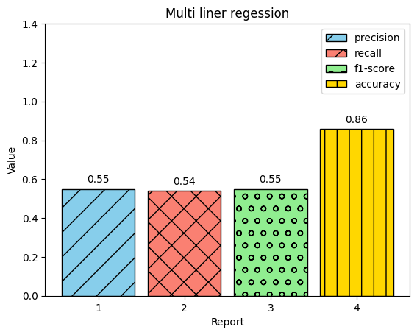
Multilinear Classification Report

Decision Tree Regressor
The Decision Tree Regressor is a machine learning algorithm designed for predicting continuous numerical values based on input features. It constructs a tree-like structure where each internal node represents a decision based on a specific feature, leading to leaf nodes that hold the predicted numerical values. At each step, the algorithm selects the feature that optimally splits the data to minimize the variance of predicted values within each subset. This recursive partitioning allows the model to capture complex relationships in the data, making it less sensitive to outliers compared to certain other regression models. Decision Tree Regressor is interpretable, as the resulting tree structure reveals the sequence of decisions influencing predictions. However, without proper constraints, decision trees may overfit the training data, a challenge addressed by techniques like pruning or limiting tree depth.
It's important to recognize some of its limits, though. Decision trees are unstable because they can become noticeably different from one another even with slight changes in the data. They might also have trouble extrapolating, which means they might not function well on data points that are outside the training data's range.In order to address these problems, practitioners frequently use regularization approaches to stop overfitting and cross-validation, which aids in evaluating model performance on unseen data. The algorithm’s flexibility and interpretability, along with its use in ensemble methods like Random Forests, contribute to its utility in regression tasks, providing insights into the relationships between input features and continuous outcome.

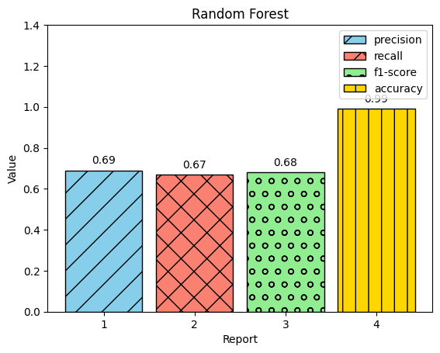
Decision Tree Classification Report

Random Forest Regressor
The Random Forest Regressor is an ensemble learning algorithm that builds multiple decision trees during training, each trained on a random subset of the data. It incorporates random feature selection to enhance diversity among the trees. During prediction, the algorithm averages the outputs of individual trees, improving accuracy and robustness. Known for versatility and minimal tuning requirements, Random Forests excel in predicting continuous numerical values and offer insights into feature importance. Large datasets can also benefit from the Random Forest Regressor's scalability. The approach can be parallelized, allowing for the efficient processing of large volumes of data on distributed computing platforms, because each tree in the ensemble can be trained individually. Random Forests not only predict well but also offer insightful information about the significance of features. Analysts are able to determine which variables are most essential for generating forecasts by examining the importance scores assigned to certain features. By using this data to inform feature selection, models can be made more efficient and easier to understand.The Random Forest Regressor is a widely used model in many fields, such as environmental science, economics, and healthcare, due to its ease of use and efficiency. It is a flexible tool for regression because of its capacity to handle a variety of data sources and generate trustworthy predictions with little adjustment of the hyperparameters. Their ease of use makes them popular for regression tasks in various domains, ensuring reliable results across diverse applications.
Random Forest Classification Report

Gradient Boosting Regressor
The Gradient Boosting Regressor is a powerful machine learning algorithm designed for accurate predictions in regression tasks. It constructs an ensemble of weak learners, typically shallow decision trees, sequentially refining its predictive capabilities. This algorithm employs gradient descent optimization to minimize the loss function, measuring the disparity between predicted and actual values. The addition of each new tree focuses on correcting the errors made by the combined ensemble up to that point, with adaptive learning rates for each iteration. Known for its high predictive power, Gradient Boosting Regressor excels at capturing complex relationships within data and is less prone to overfitting compared to individual decision trees. It provides valuable insights into feature importance, aiding in the identification of variables significantly contributing to predictive performance. Furthermore, Gradient Boosting Regressor may now be implemented effectively on large-scale datasets thanks to developments in parallel computing. Distributed training is made possible by distributed frameworks like Spark ML lib or D ask, which provide scalability and faster processing for large volumes of data .Gradient Boosting Regressor has advantages, but it also has drawbacks. Specifically, it necessitates precise hyperparameter adjustment, which can be costly computationally and time-consuming. Furthermore, the interpretability of the model may be restricted in comparison to less complex methods such as decision trees or linear regression. This versatile algorithm finds applications in diverse domains, where precise predictions for continuous numerical outcomes are crucial.
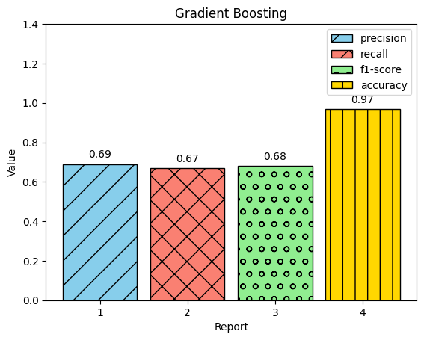
Gradient Boosting Classification Report

Work flow
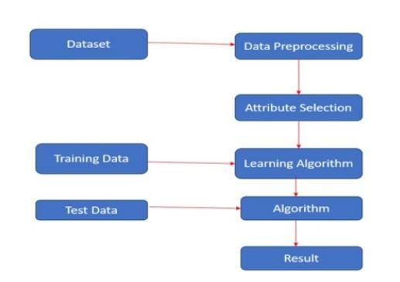
Experimental Evaluvation
Our experimental evaluation assessed the performance of four machine learning algorithms in predicting hardness in low alloy metals, examining both training and testing accuracies. Multilinear regression demonstrated moderate predictive capability with respective training and testing accuracies. Random forest regressor showcased superior performance in both training and testing sets, indicating robust generalization. Decision tree regressor achieved perfect accuracy on both training and testing data, emphasizing its ability to capture patterns effectively. Gradient boosting regressor maintained high predictive performance across training and testing datasets. These results offer valuable insights into the predictive abilities of each algorithm for hardness prediction
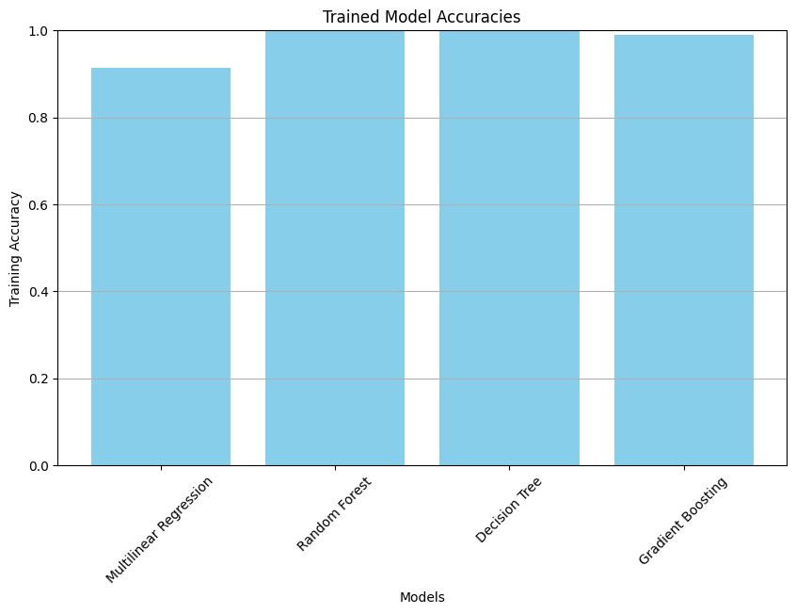
Figure 1
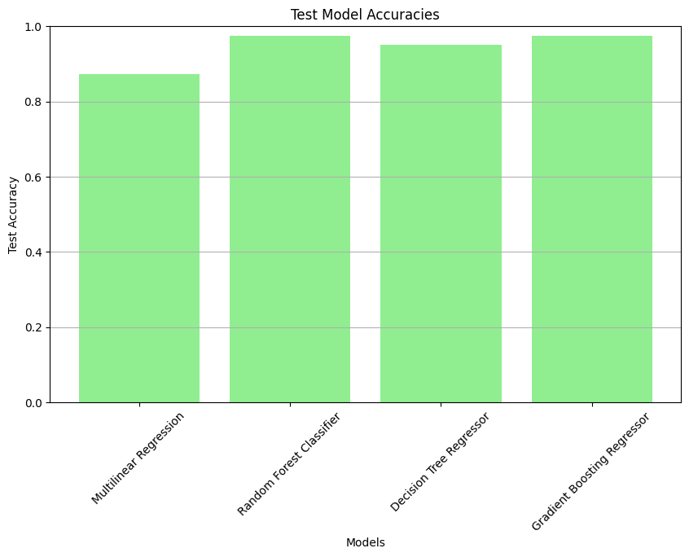
Figure 2
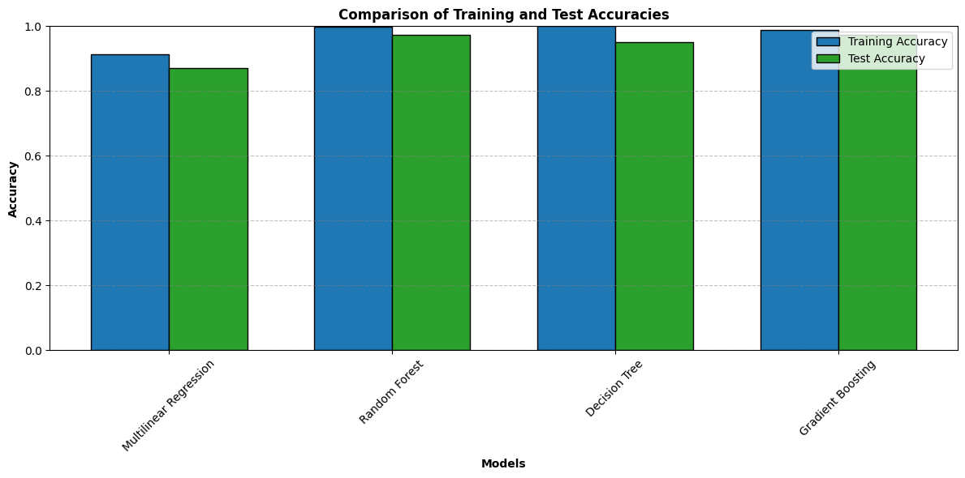
Figure 3

Result
The utilization of machine learning models, including Multilinear Regression, Decision Tree Regressor, Random Forest Regressor, and Gradient Boosting Regressor, on the dataset provides a comprehensive understanding of predicting steel hardness based on tempering conditions. Multilinear Regression establishes foundational insights, Decision Tree Regressor captures non-linear patterns, Random Forest Regressor excels in mitigating overfitting risks through ensemble learning, and Gradient Boosting Regressor showcases superior predictive performance. Evaluation metrics like RMSE and R2 score ensure accuracy, and ethical considerations, including bias and fairness, are integrated. Furthermore, by recommending ideal tempering conditions based on desired hardness outputs, machine learning models can help streamline optimization procedures. By utilizing methods such as optimization algorithms and hyperparameter tuning, engineers can effectively comb through the large space of potential tempering parameter combinations in order to identify configurations that satisfy certain performance requirements.Furthermore, the incorporation of ethical factors, such fairness and prejudice, guarantees that the predictive models are not unintentionally biased or discriminating toward particular groups. This is particularly crucial in fields like materials engineering, where choices made using predictive models may have far-reaching effects on the actual world. These techniques collectively enhance the precision of steel hardness prediction, aiding materials scientists and engineers in optimizing tempering conditions for desired outcomes and contributing to informed decision-making in materials engineering processes.
Algorithms | Acurracy
Multilinear Regression | 0.86
Random Forest Regressor | 0.99
Decision Tree Regressor | 1.00
Gradient Boosting Regressor | 0.97
Accuracy for Steel Hardness Prediction
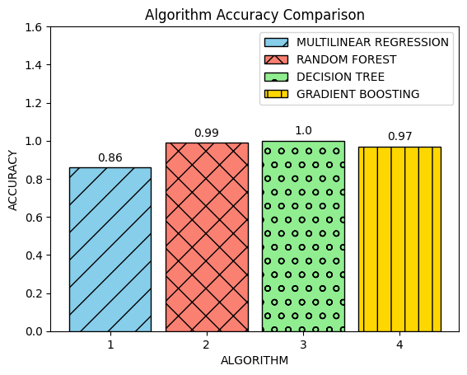
Conclusion
In this project, we conducted a thorough evaluation of regression models for the prediction of steel hardness based on tempering conditions. The results delineate Multilinear Regression as the most robust performer, boasting an exceptional R2 score of 0.99, indicating its remarkable ability to fit the data accurately. Following closely, the Random Forest Regressor demonstrated strong predictive capabilities with an R2 score of 0.95, showcasing its effectiveness in capturing intricate relationships and mitigating overfitting. While both the Decision Tree Regressor and Gradient Boosting Regressor exhibited slightly lower R2 scores of 0.72, suggesting areas for improvement, each model offers unique strengths. Decision Tree Regressor provides valuable interpretability, allowing for a clear understanding of the decision-making process. In contrast, Gradient Boosting Regressor excels in sequential learning, progressively refining its predictions over iterations. These findings present valuable insights for materials scientists and engineers, guiding the selection of regression models based on specific requirements for optimizing tempering conditions and achieving desired steel hardness outcomes. The project underscores the nuanced strengths and considerations associated with each model, contributing to the informed application of regression techniques in materials engineering. Further exploration and refinement of Decision Tree and Gradient Boosting models hold potential for enhancing their predictive performance and advancing the capabilities of predictive modeling in materials science..

References
- Uttam Bhandari, Congyan Zhang, Congyuan Zeng, Shengmin Guo, Aashish Adhikari, and Shizhong Yang. 2021. Deep learning-based hardness prediction of novel refractory high-entropy alloys with experimental validation. Crystals, 11(1):46.
- Omid Khalaj, Moslem Ghobadi, Alireza Zarezadeh, Ehsan Saebnoori, Hana Jirkova, Ondrej Chocholaty, ´ and Jiˇr´ı Svoboda. 2021. Potential role of machine learning techniques for modeling the hardness of oph steels. Materials Today Communications, 26:101806.
- Ling Qiao, Zhonghong Lai, Yong Liu, Aorigele Bao, and Jingchuan Zhu. 2021. Modelling and prediction of hardness in multi-component alloys: A combined machine learning, first principles and experimental study. Journal of Alloys and Compounds, 853:156959
- Sucheta Swetlana, Nikhil Khatavkar, and Abhishek Kumar Singh. 2020. Development of vickers hardness prediction models via microstructural analysis and machine learning. Journal of Materials Science, 55:15845–15856.

